Project Initialization and Planning Phase

Date | 16 August 2026
Team ID | Individual
Project Name | India's Agricultural Crop Production Analysis
Maximum Marks | 3 Marks

Define Problem Statements (Customer Problem Statement Template):
I am an agricultural analyst, I'm trying to analyze India's crop production data, but the dataset contains a large amount of raw information because it includes different states, crops, seasons, area, and production, which makes me feel that identifying important patterns and trends is difficult.

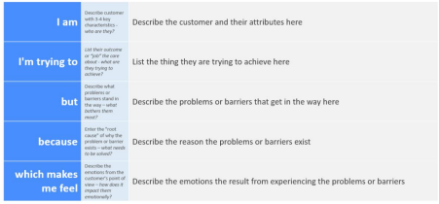
Reference: https://miro.com/templates/customer-problem-statement/
Example:


Problem  Statement (PS) | I am  (Customer) | I’m trying to | But | Because | Which makes me feel
PS-1
PS-2

